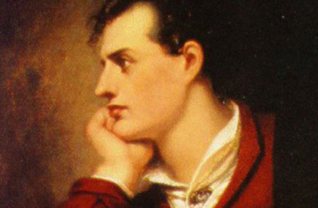 George Gordon, Lord Byron

Byronic Hero: A kind of hero found in several of the works of Lord Byron. Like Byron himself, a Byronic hero is a melancholy and rebellious young man, distressed by a terrible wrong he committed in the past. He has a dark, handsome appearance; is brilliant but cynical and self-destructive; wanders and searches in isolation; is haunted by some secret sin or crime (sometimes hints of forbidden love); appeals to society by standing apart from society, superior yet wounded or unrewarded.
Romantic Orientalism: (also "Oriental exoticism" or "Oriental fantasy") A fascination, particularly seen in Romantic literature, on the geography and culture of large parts of Asia and North Africa, plus some of what we now think of as Eastern Europe. Above all, from a British point of view, "Orientalism" connotes foreignness or otherness — things decidedly not British — and it sometimes seems as if the "East" signified by "Orient" is not only what is east of Europe and the Mediterranean but everything east of the English Channel. Orientalism questions national identity, cultural difference, the morality of imperialist domination, and the consequent anxiety and guilt concerning such issues. (Norton Online)
Don Juan
Byron’s deft parody of the lofty epic form, his wide-ranging satire on most things Romantic, and his hilarious irreverence for morals, religion, and authority of all types make Don Juan an incredibly appealing text for readers. Perhaps the only subject upon which Byron lavishes genuine respect is sexual love, and in this way the poem conforms to what non-literary readers expect from the term “romantic.” But nothing in this romping “epic survey of modern folly” escapes censure, not even Byron himself, as he playfully conceals and reveals his biographical details and personal opinions in the voice of the charming, garrulous, and worldly narrator. This great comic narrator traces its origins to the intrusive narrators of Fielding and Sterne and looks forward to the self-conscious narrations of modern and postmodern literature, as he digresses, cajoles, ﬂirts, and conspires with, winks at, and teases the reader. As the ottava rima stanzas (an eight line stanza form, rhyming abababcc, using iambic pentamer) and the comic rhymes ﬂow on with an air of effortless improvisation, Byron’s spirit seems effervescent and mobile, and his attitudes range from sardonic irony to high gaiety.

Discussion Questions:

1. Anti-romantic Romantic: Byron’s attitude toward Wordsworthian Romanticism was largely parodic, and this poem delights in raising the elder poet as an image of conventional—and authoritative—poetic stodginess. Characterized by its skepticism and irony, and often a late-Romantic malaise, Byron’s work neither idealizes an imaginary past nor manifests an Enlightenment belief in human perfectibility and progress nor hopes for a new golden age in the present. Find some examples in the Don Juan that show Byron to be an anti-romantic Romantic.

2. Self-conscious Literary Craft. In this strategy, primary attention is paid to Byron’s narrator and the frequent commentary he makes on his own craft: for example, “But this last simile is trite and stupid”(1.440). In part, his intrusive comments appear to accommodate the demanding rhyming pattern of the ottava rima, but they are so frequent and playful (and often quite accurate) that the readers sense Byron is teasing us. Find more examples of Byron’s self-conscious literary craft and explore its effect on the text.

3. Analyze the famous first line “I want a hero.” According to the defintion above, is Don Juan a Byronic Hero?

4. How does Don Juan present Orientalism (see definition above)?

5. How does “She walks in beauty” and “When we two parted” compare or contrast to Don Juan?

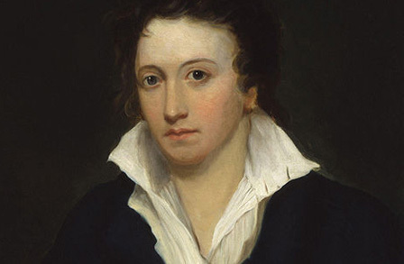 Percy Bysshe Shelley

In A Defense of Poetry, Shelley states “A Poet is a nightingale, who sits in darkness and sings to cheer its own solitude with sweet sounds; his auditors are as men entranced by the melody of an unseen musician, who feel that they are moved and softened, yet know not whence or why.” Shelley’s image of the poet as an isolated nightingale can be understood as a reﬂection of his own experience, as he wrote most of his major works in exile without an audience, but the description of the enchanted auditors and the mysterious power of poetry is an expression of his idealized belief in the power of poetry to regenerate the individual and thus to improve society itself. Shelley’s incisive criticism of his society’s political and moral ills in many of his poems is balanced by his fervent belief in the capacity for poetry to renew a vision of the permanent forms of beauty and truth.
In “Mont Blanc,” you will see irregularity, perhaps even whimsey, in Shelley's use of rhyme throughout this poem. This piece functions much like Wordsworth's “Lines above Tintern Abbey,” alternating between vivid description of a natural scene and the poet's reflections upon the scene. The conclusion to which those reflections lead is quite different from Wordsworth's. The poet writes from the perspective of a deep gorge, the ravine, as he calls it, of the river Arve, a mountain stream tumbling from the base of a glacier on a side of the highest peak in the Alps. Like countless other travelers before him, Shelley finds this alpine scene full of the sublime, a quality which rouses at the same moment the mixed emotions of reverence, awe, and dread. (You will encounter the word “sublime” often in Romantic literature.)

Discussion Questions

1. Compare and contrast “Mont Blanc” to Wordsworth’s “Tintern Abbey.”

2. Choose any line in the poem that makes you feel “moved and softened, yet know not whence or why.”

3. In lines 139-141, the poet notes the correspondence between the power that operates the human mind and the power that makes the laws of nature, a typical Romantic insight into the relationship between the human Imagination and the spiritual heart of nature. State in your own words the essence of the question these lines ask.

